Project CM

Version 1.0

Revision History

|  |  |  |  |
| --- | --- | --- | --- |
| **Date** | **Version** | **Description** | **Author** |
| 17/Oct/2013 | 1.0 | Initial UC description | Storm Cloud Development |
|  |  |  |  |
|  |  |  |  |
|  |  |  |  |

Table of Contents

1. Use-Case Name 4

1.1 Brief Description 4

2. Flow of Events 4

2.1 Basic Flow 4

2.2 Alternative Flows 4

2.2.1 < First Alternative Flow > 4

2.2.2 < Second Alternative Flow > 4

3. Special Requirements 5

3.1 < First Special Requirement > 5

4. Preconditions 5

4.1 < Precondition One > 5

5. Postconditions 5

5.1 < Postcondition One > 5

6. Extension Points 5

6.1 <Name of Extension Point> 5

# Use-Case Name

## Brief Description

If the user creates or edits a new appointment he has the opportunity to book meeting rooms for this appointment. After the user has booked a room, he can delete the booking or edit it.

# Flow of Events

## Screen Flow

The picture shows the screen flow of the CRUD for booking meeting rooms the address book. The functions work on a contact in the address book.

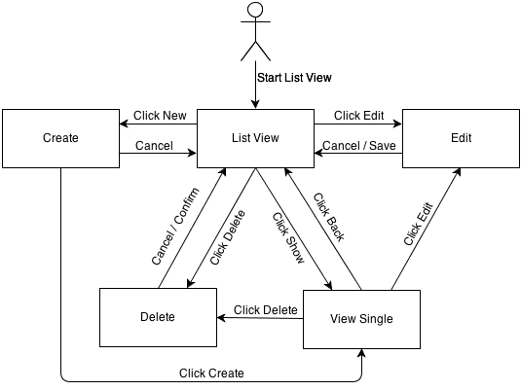

## Use Case Flows

### Show all conatacts (List View)

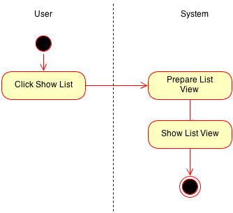

### Show single contact (View Single)

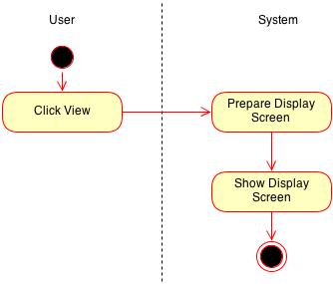

### Create new contact (Create)

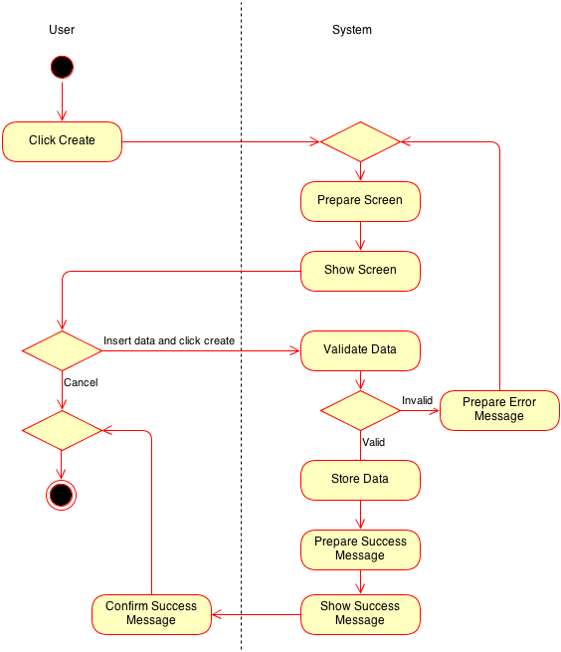

### Edit contact (Edit)

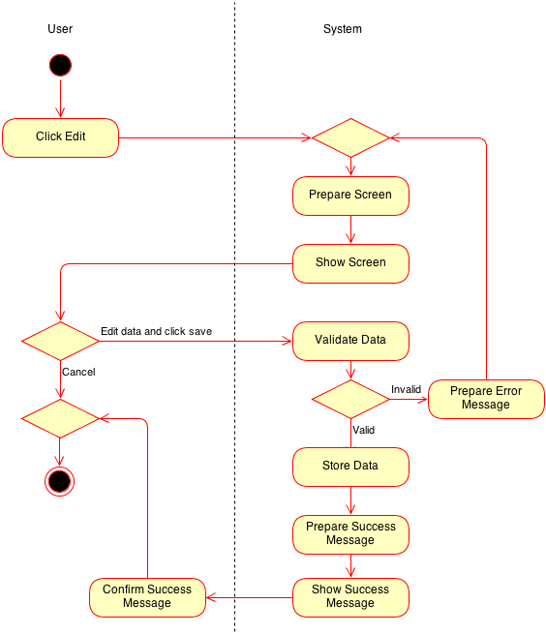

### Delete contact (Delete)

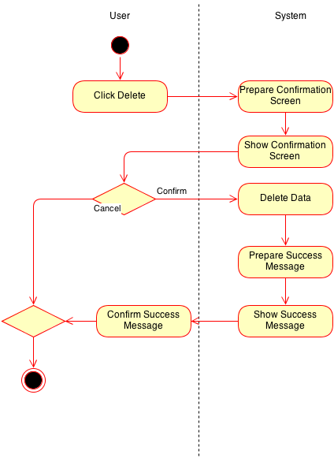

# Special Requirements

[A special requirement is typically a nonfunctional requirement that is specific to a use case, but is not easily or naturally specified in the text of the use case’s event flow. Examples of special requirements include legal and regulatory requirements, application standards, and quality attributes of the system to be built including usability, reliability, performance or supportability requirements. Additionally, other requirements⎯such as operating systems and environments, compatibility requirements, and design constraints⎯should be captured in this section.]

## < First Special Requirement >

# Preconditions

## Room

* must exist
* must be free at requested period of time

# Postconditions

## Room

* does not exist
* can be free after requested period of time
* can be booked after requested period of time

# Extension Points

n/a